*Lab 6: Op-amps II*

Physics 411

John Waczak

12/01/2016

Lab Partner: Kyle Tafoya

Introduction

Lab 6 revisited the integrated circuit analyzed in lab 5 called the operational amplifier (forthwith denoted ‘op-amp’). As was mentioned before, the op-amp is a complicated network of transistors, resistors, and capacitors that allows one, self-contained device to perform a plethora of task that range from amplifying an input signal to inverting, summing, differentiating, integrating, filtering, etc... The details of how the internal mechanism functions are beyond the scope of this class however there are two key assumptions dubbed “the Golden Rules of op-amps” that allow us to predict the behavior between the input and output pins. They are as follows:

1. The output does whatever it must to keep the voltage difference between the two inputs zero.
2. The inputs draw no current.

Lab 6 consisted of six experiments. The first two further tested the physical qualities of the op-amp – particularly, it’s slew rate and offset voltage. The next two experiments analyzed two further uses of the op-amp as both an integrator and a differentiator. Next the effect of positive feedback was analyzed by comparing two circuits one with zero feedback and another configured for positive feedback. Finally, an interesting circuit called the “RC oscillator” was analyzed as it produced a periodic output without being connected to a separate input supply.

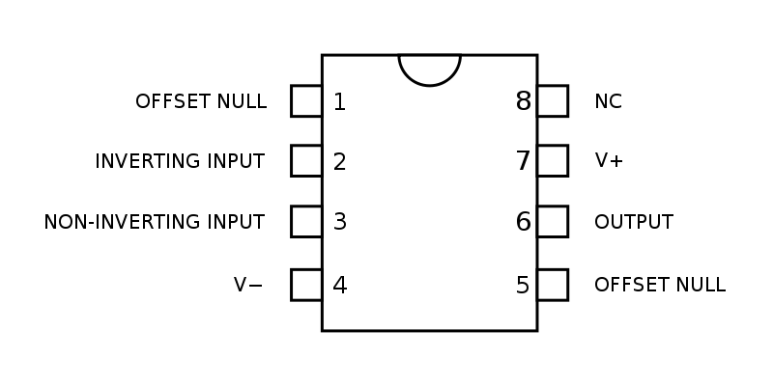These experiments together with lab 5 paint a good picture for both the traits of the operational amplifier as well as many of its uses. The following lab report will detail the findings of those experiments performed. For reference I have included a pinout diagram of the standard eight pin op-amp in figure one below.

Figure 1: op-amp pinout diagram

Procedure

1. *Slew Rate*

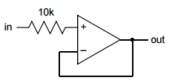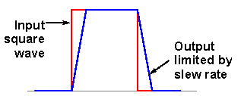The slew rate for an op-amp is defined as the rate of change in output voltage for a step change in the input. Essentially, this is measured as a change in output voltage over a given period of time and can be visualized as a time delay or lag on the output pin due to the complicated inner workings of the integrated circuit. Figure two to the right shows an example of an output signal (blue) affected by the slew rate of an amplifier for an input sinewave (red). In order to measure this affect, the circuit shown in figure 3 was built. An input square wave was passed to the positive input terminal and the output was measured with the oscilloscope. The

Figure 3: Slew Rate Circuit

Figure 2: Slew Rate visualization

Frequency was increased until we could see the effect clearly, and the waveform was captured. The slew rate was then determined by measuring the slope on the right hand side of the output wave as well is the left hand side. The measurements were first made for the LM741 and then repeated for the TL071.

These values were then compared to the reported values of 0.5 V/μs for the LM741 and 8 V/μs for the TL071. Afterwards, the input form was changed to a sinewave and the outputs were recorded.

1. *Offset voltage*

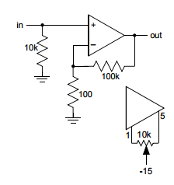Because manufacturers cannot make a perfect op-amp, there is often what is called an offset voltage – that is a DC offset on the output pin that causes all outputs to drift from the expected value by a constant. In order to account for this, pins 1 and 5 on op-amps can be used to tune the chip in order to minimize this affect. The second experiment sought to perform this adjustment by crafting the circuit shown to the right figure 4. The circuit is a x1000 non-inverting amplifier designed so that the op-amp itself can be used to aid in the offset adjustment. By tuning the potentiometer with a small screwdriver, the effect on the output signal for a grounded input could be easily seen.

Figure 4: Offset Trimming Circuit

1. *Integrator*

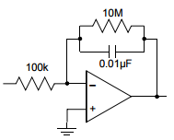As mentioned in the introduction, experiments C and D looked at uses of the op-amp for different circuits. The first analyzed is called the ‘integrator’ and is designed to behave similarly to an RC circuit. Figure 5 to the right shows the diagram used to build the integrator circuit. This was driven with a 1kHz square wave and the output was captured using the oscilloscope. Other signal shapes were then tested to see if the circuit continues to behave as an integrator. Finally, the 10MΩ resistor was removed and the resulting output signal was measured again.

Figure 5: Integrator Circuit

Using the golden rules, we can conclude that all of the current passes along the feedback loop. The associated time constant for the circuit, $τ=RC=100k*0.01μF=0.001s$. After these tests, Ali’s labview program was used to capture the frequency response of the circuit.

1. *Differentiator*

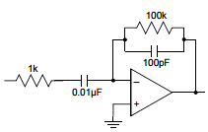The fourth experiment analyzed the op-amp configuration dubbed the ‘differentiator’ circuit. This circuit is named as such because the outputs signal acts as if it is the derivative of the input signal. The circuit shown in figure 6 was built and a 1kHz triangle wave was passed to the input. For an input triangle wave we would expect the output to have some kind of gain but also to be the shape of a square wave as the derivative of a line with some slope is a straight line. After testing the triangle-wave input, other input waveforms were tested to see if the behavior of the circuit was consistent with its name. After these tests, Ali’s labview program was used to capture the frequency response of the circuit.

Figure 6: Differentiator Circuit

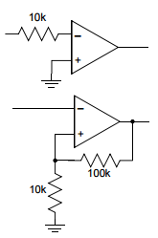

1. *Positive Feedback*

In previous labs and examples, the effect of adding a positive feedback loop to op-amp circuits was tested. Experiment E looked at the effect of and possible uses for positive feedback. In order to analyze this affect, the two circuits shown in figure 7 were made. Inputs of various waveforms (sine and square) were passed to the input pin and the output waveform was captured using the oscilloscope. This circuit, called the comparator is expected to be low or high when the input signal is positive or negative.

Figure 7: Comparator circuits

1. *RC oscillator*

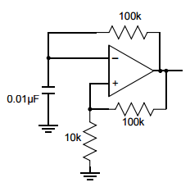The final experiment tested the circuit dubbed the ‘RC oscillator’. This circuit is essentially the same as the comparator used in the positive feedback experiment with the addition of a small capacitor between the input and ground. Strangely though, there is no input signal used. Figure eight to the right shows a diagram for the circuit that was built. The oscillation on the capacitor was captured by attaching the oscilloscope probe between ground and the capacitor connected to the input.

Figure 8: RC oscillator circuit

There was some difficulty with seeing the oscillating output so the value of the capacitor was changed to 0.1μF and the corresponding resistor was changed to 100kΩ. The feedback loop resistors were both changed to 10kΩ so that there would be zero gain and we could see larger voltages on the capacitor. The time constant for the circuit is $τ=RC=100k*0.1μF=0.01s$.

Results

1. *Slew Rate*

The tables below show the results for the slew rate testing:

|  |  |  |  |  |  |  |  |  |
| --- | --- | --- | --- | --- | --- | --- | --- | --- |
| **LM741** | | | | | | | | |
| square wave @ 1 kHz | | | |  | sine wave @ 100 kHz | | | |
|  | Voltage | Time (us) | Rate (V/us) |  |  | Voltage | Time (us) | Rate (V/us) |
| Slew Rate Left | 5 | 6 | 0.83 |  | Slew Rate Right | 3.8 | 5.7 | 0.67 |
| Slew Rate Right | 5 | 7.4 | 0.68 |  | Documented Value | | | 0.50 |
| Documented Value |  |  | 0.50 |  |  |  |  |  |
|  |  |  |  |  |  |  |  |  |
| **TL071** | | | | | | | | |
| square wave @40 kHz | | | |  | sine wave @ 2.0MHz | | | |
|  | Voltage | Time (us) | Rate (V/us) |  |  | Voltage | Time (us) | Rate (V/us) |
| Slew Rate Left | 5.08 | 0.5 | 10.16 |  | Slew Rate Right | 2.48 | 0.252 | 9.84 |
| Slew Rate Right | 4.92 | 0.43 | 11.44 |  | Documented Value | | | 8.00 |
| Documented Value |  |  | 8.00 |  |  |  |  |  |

The average slew rate for the LM741 (left and right sides under square wave input) is 0.755 V/µs. This value is larger than the reported 0.5 V/µs by roughly 25%. Surprisingly though, for a sinewave input, the value was measured to be 0.67 V/µs, a much closer value.

For the TL071 op-amp, the average slew rate between the right and left sides of the signal was 10.8 V/µs. This value was roughly 35% over the reported 8.00 V/µs measurement. Again, the sinewave slew rate was measured to be much closer to the reported value at 9.84 V/µs.

If the slew rate represents the rate of change of the voltage over a given period of time, it is clear then why one would likely choose to use the TL071 as the rate is larger by an order of magnitude. A fast slew rate corresponds to a shorter lag on the op-amp output and so the TL071 essentially reacts faster than the LM741 to input AC signals.

1. *Offset Voltage*

The DC offset voltage was measured to be 5.0 volts initially before the trimming circuit was employed. The reported value for the typical voltage offset is 6.0 V suggesting that our op-amp was functional and not damaged in any noticeable way.

Adding the trimming network allowed us to trim the offset to the 100 mV range but it was extremely difficult to get the circuit to rest perfectly at zero as it tended to float around of a range of values from -50mV to + 50 mV. By changing the value of the potentiometer, perhaps this control could be improved. For example, a 20MΩ potentiometer would allow us to further reduce the voltage to zero and perhaps give us some better control.

1. *Integrator*

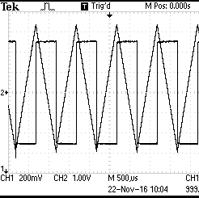

Graph one to the right shows the captured output signal and the input square wave. As described previously, the circuit behaves as an integrator; the input square wave is integrated into a triangle as flat lines integrate to lies with a constant slope. Graph one does not show the 1.4 volt dc offset that was measured as the window had to be adjusted so that the two waveforms could be compared.

Graph 1: Integrator behavior at 1kHz

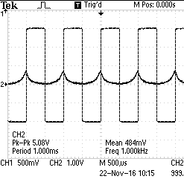

Trying to adjust the DC offset on the function generator resulted in the output being sent directly to zero with slight bumps at the front of each step as evidenced in graph 2 to the right. When set to the same voltage scale, nearly no output signal is observed.

Graph 2: Adjusted input offset and resulting output

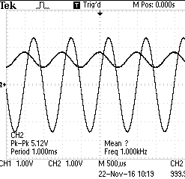

When the input signal was changed to a sinewave, the same sort of behavior was noticed: the circuit integrated the input, shiftig the sinewave by pi/4 radians and producing a cosine however the resulting output was still offset by that 1.4 volts. Graph 3 to the right shows the captured output behavior for an input sinewave.

Graph 3: sinewave input

Taking away the 10MΩ resistor also led to some interesting behavior. Graphs 4 and 5 show the ‘fuzziness’ that appeared on the output when the resistor was removed. The timescales for the two are different such that you can see the full period of the output wave in graph 4 and graph 5 shows a zoomed in picture that magnifies the image of the noise.

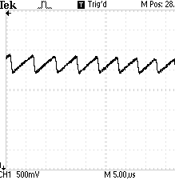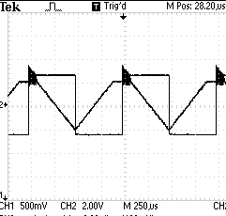

Graph 5: no resistor, magnified fuzziness

Graph 4: no resistor, entire period

Thus it would appear that the 10 MΩ resistor serves to get rid of this signal noise.

Next we measured the frequency response of the circuit expecting it to behave as a low pass filter based off of the RC circuit’s similar integrator behavior. Graph 6 below shows the output of the labview software for the frequency sweep:

Graph 6: Frequency Response - Integrator Circuit

As the graph shows, the behavior of the circuit is in fact that of a low pass filter with a cutoff frequency in the 10-100kHz region.

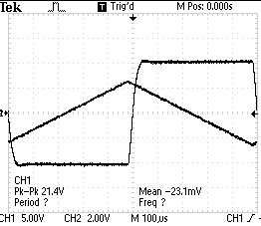

Graph 7: Differentiator output - triangle wave input

1. Differentiator

Graph 7 shows the captured output signal for an input triangle wave at 1kHz. As the graph suggests, the differentiator does in fact differentiate the input signal. The slanted liens of the triangle wave are integrated to flat lines as the derivative of a degree one polynomial is a constant.

This behavior was not consistent for other input waveforms. In fact, the only one it worked for was for the original triangle wave input. Graph 8 below shows the output for a sinusoidal input waveform. Perhaps this weird behavior is an artifact of the two different capacitors having different frequency responses but the behavior is still very strange.

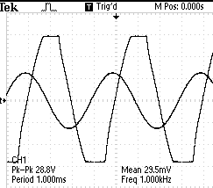

Graph 8: Differentiator - sinewave input

As in the previous experiment, next we used the labview software to analyze the frequency response for the differentiator circuit expecting to see it behave as a high pass filter (similar to the CR and RL circuits previously studied). Graph

Graph 9: Differentiator frequency response

As the graph shows, the op-amp clearly behaves like the classic high pass filter until it reaches the critical frequency. After that the gain begins to decrease at a somewhat steady rate as the frequency is increased. My first consideration was that this might be due to the slew rate of the op amp however this was not a problem for the integrator so this behavior must be some other artifact of the internal mechanism of the op-amp.

1. Positive Feedback

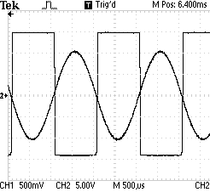Data for the response of the comparator with no feedback loop can be seen in the graphs below:

Graph 11: Comparator - Sinewave input

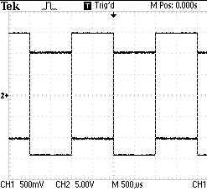

Graph 10: Comparator - Square wave input

As the graphs reflect, the comparator sends the output to high for positive inputs and to low for negative inputs. Through tweaking the amplitude of the input sinewave we found that 126.5 mVpp was required to see an output from the op amp.

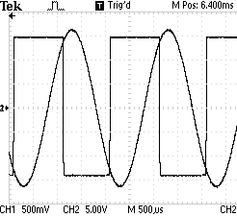This was repeated for the comparator with a positive feedback loop. Graphs 12 and 13 show the response for both square and sinusoidal inputs.

Graph 13: Comparator - sinewave input with + feedback

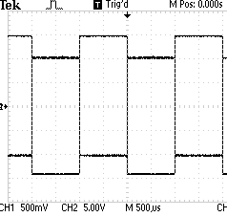

Graph 12: Comparator - Square wave input with + feedback

As the graphs reflect, the behavior was the same for he comparator with no feedback. When positive feedback was introduced however, the output waveform experienced some phase shift such that the positive and negative regions do not match precisely with those from the input signal.

Similarly, tweaking the amplitude of the input sinewave found that a minimum voltage peak to peak required to see an output signal was 1.4 Vpp. This suggests that, as expected, adding a feedback loop affects the gain of the op amp.

1. RC oscillator

For the final experiment, the output waveform was captured again using the oscilloscope. Before analyzing the results however, recall that the time constant for the RC oscillator was previously calculated to be $0.01s$. This corresponds essentially to how long it takes to charge the capacitor to 63% and how long it takes to discharge the capacitor to 37%. Thus we should expect that the $τ+0.37τ=0.01+0.0037=0.0137s$ should be the amount of time it takes to charge or discharge. From this we can estimate that the period of oscillation for the RC oscillator should just be 2 * 0.0137 = 0.0274 s or roughly 27ms.

Graph 14 shows the output of the RC oscillator circuit

Graph 14: RC oscillator output

The output looks exactly like the charging and discharging for a capacitor we’ve seen previously in the capacitor lab. The measured period of oscillation was calculated by taking the difference in time between two successive peaks. The first positive peak occurs at T = 0.00684 s and the second occurs at T = 0.02838 giving a period of 0.02154 s or 22 ms. This is extremely close to the theoretical value and likely suggests that the oscillation is slightly too fast for the capacitor to charge all the way. This makes sense as we should expect to see the capacitor charging to +/- 7.5 volts as with zero gain on the feedback the voltage divider simply divides the 15 volt input by two but the measured peaks occur roughly at 6.24 volts.

This is really cool as the charging and discharging of the capacitor along with the feedback was enough to drive the output of the op-amp. No input was needed.

Conclusion

Lab 6 demonstrated many more of the physical traits and uses for the op-amp. The property known as the slew rate was determined and its effect on the output signal of the op amp was illustrated. The process of trimming the factory offset voltage was also explored. Finally, 4 circuits were analyzed two of which demonstrated possible uses for the op-amp while the other two examined how playing with the feedback loop from the output to the input can dramatically impact the behavior of the circuit.

Some experiments like for the integrator and differentiator circuits could have benefited from some more analysis in the lab however time was a key factor in the completion of these experiments. All in all, I feel like a have a much keener understanding for how to use op amps but would still like to analyze the details of their inner workings more closely in the future.

Works cited

1. <http://www.radio-electronics.com/info/circuits/opamp_basics/operational-amplifier-slew-rate.php>
2. <http://physics.oregonstate.edu/~mcintyre/COURSES/ph411/ph411lab6.pdf>
3. <http://physics.oregonstate.edu/~mcintyre/COURSES/ph411/ph411labwriteup.pdf>